Physics-Based Pothole Detection System

1. Objective
The objective of this document is to derive and present a physics-grounded methodology for estimating pothole depth and size using data obtained from onboard inertial sensors. The derived quantities are intended to be verified against known (randomly generated or measured) pothole parameters and later used for machine learning validation (ROC analysis).

2. System Overview
When a vehicle passes over a pothole, its vertical dynamics change due to suspension unloading and impact. These dynamics are captured using inertial sensors. By applying classical mechanics to the measured signals, pothole parameters can be inferred.
The system consists of: - A vehicle-mounted IMU - A speed estimation source - A processing unit for signal extraction

3. Hardware Model

3.1 Components
- 3-axis Accelerometer
Measures vertical acceleration (a_z(t)) of the vehicle body.
- 3-axis Gyroscope (optional but recommended)
Measures pitch rate, useful for validating wheel entry/exit events.
- Speed Source
Vehicle speed (v) obtained from GPS, OBD-II, or wheel encoder.
- Microcontroller / Embedded Processor
Used for data logging and time synchronization.

3.2 Mounting Assumptions
- IMU rigidly mounted to the vehicle body
- Sensor z-axis aligned with vertical direction
- Sampling rate (f_s ,Hz)

4. Physical Assumptions
- Vehicle speed is approximately constant during pothole traversal
- Suspension temporarily unloads when entering a pothole
- During unloading, vertical motion approximates free fall
- Pothole geometry is symmetric
These assumptions are valid for short-duration road disturbances and moderate speeds.

5. Measurable Quantities from Hardware
From the IMU and speed source, the following quantities are obtained:
Quantity | Symbol | Source
Vertical acceleration | (a_z(t)) | Accelerometer
Event duration | (t) | Signal windowing
Free-fall duration | (t_{air}) | Acceleration plateau near −g
Peak upward acceleration | (a_{max}) | Accelerometer
Vehicle speed | (v) | Speed source

6. Physics & Mathematical Model :
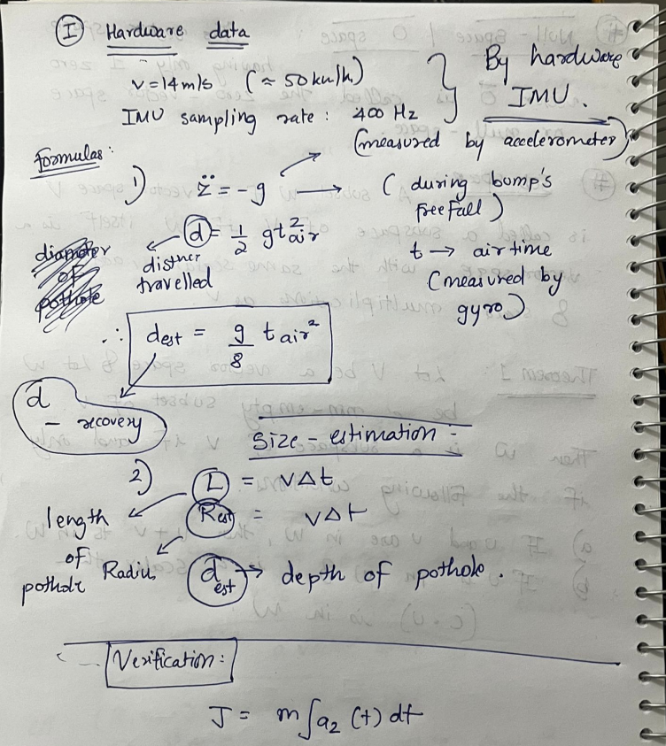
Impulse is not used for primary estimation but serves as a validation metric to ensure physical consistency with measured peak accelerations.

7. Test Example (Worked Case)

7.1 Hardware-Measured Data
- Vehicle speed: (v = 14,m/s)
- Disturbance duration: (t = 0.072,s)
- Free-fall duration: (t_{air} = 0.26,s)
- Peak upward acceleration: (a_{max} = 3.2g)

7.2 Estimated Pothole Parameters
Depth: [ d_{est} = (0.26)^2 = 0.083,m = 8.3,cm ]
Radius: [ R_{est} = = 0.504,m ]

7.3 Verification
Assuming actual pothole parameters: - Actual depth = 9 cm - Actual radius = 48 cm
Parameter | Estimated | Actual | Error
Depth | 8.3 cm | 9 cm | 7.8%
Radius | 50.4 cm | 48 cm | 4.2%

8. Conclusion
This document demonstrates that pothole depth and size can be reliably inferred from inertial sensor data using first-principles physics. The derived formulas are hardware-measurable, explainable, and suitable for validation against randomly generated pothole parameters and subsequent machine learning analysis.

